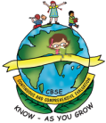
GREENWOOD PUBLIC SCHOOL
ADITYAPURAM, GWALIOR
SESSION 2023-24 : SYLLABUS FOR THE MONTH OF JULY : CLASS-NURSERY
SUBJECTS | SYLLABUS | ACTIVITY + USE OF ICT | PARENTS INVOLMENT
ENGLISH  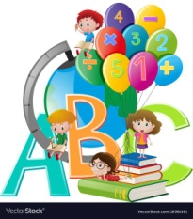  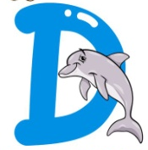  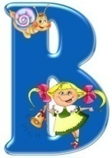  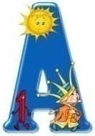 | ORAL:  Rhymes-  1. Apple  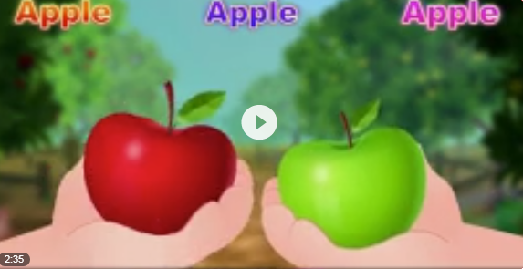  2. Early to bed  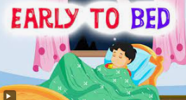  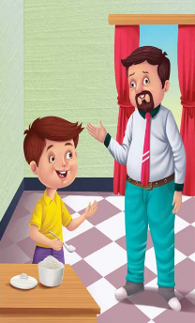  3. Johny, Johny  Sentence Structure- Move in a line.  Go for handwash.  Vocabulary Building-  Kitchen, Building, Living Room, Fruits, Flowers, Birds, Insects  Recognition- A, B, C, D  WRITTEN:  Practicing Strokes- Standing lines, Sleeping lines, Slanting lines, Curves  Alphabets- A,B  Workbook- Page no. 5-10 | Rhymes- 1. Apple  https://youtu.be/bqnExs-ScwM  2. Early to bed  https://youtu.be/1FXGT4UtZCo  3. Johny, Johny  https://youtu.be/F4tHL8reNCs  Phonics Sound  https://www.youtube.com/watch?v=hq3yfQnllfQ  Alphabet Song  https://www.youtube.com/watch?v=zAlX1V3lK5s  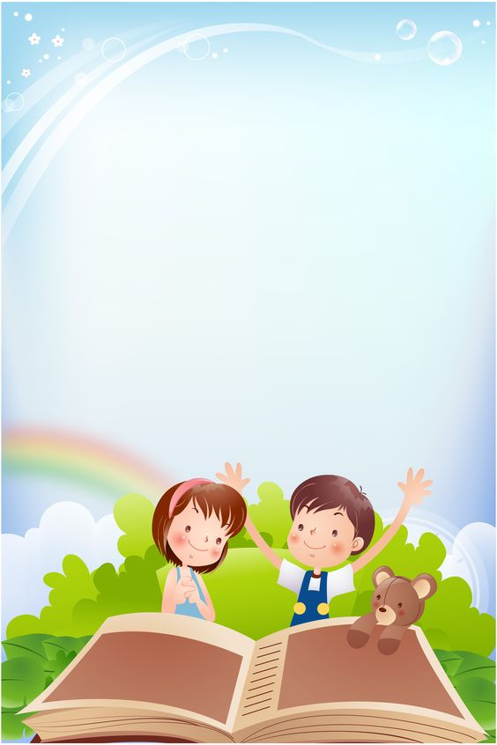  Activity Work  - ‘Look and Identify’ Game will be played for the recapitulation of the letters and their related objects. Learners will be asked to look and identify the objects as shown by the teacher.  - ‘Show and Tell’ Picture Reading Activity | - Help your child in learning rhymes.  - Help your child in doing his/her homework.  - Motivate your child to use the vocabulary words in daily life.
SUBJECTS | SYLLABUS | ACTIVITY + USE OF ICT | PARENTS INVOLMENT
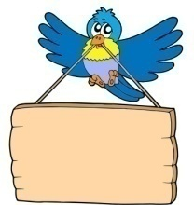  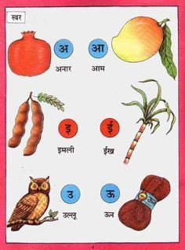  HINDI | ekSSf[kd%&  dfork,¡&  1- çkFkZuk  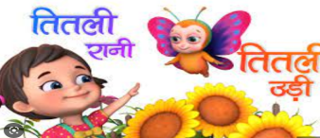  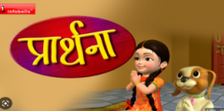  2- frryh  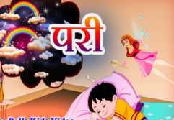  3- ijh  Loj o.kZ& v ls bZ rd  okD; jpuk& ;g esjk Ldwy gSA  v{kjksa dh igpku& v ls bZ rd  fyf[kr%&  lajpuk&vkM+h frjNh js[kk,¡] xksykdkj ,oa v)Zxksykdkj lajpuk,¡] Loj&v]vk  v{kj ys[ku& ist ua- 2 ls 5 | Loj o.kZekyk xhr  https://www.youtube.com/watch?v=TM83zp1AkUM  Activity work  - dforkvksa dks lLoj okpu  - Þns[kks vkSj crkvksaÞ [ksy ls fp=ksa dks igpkudj crk,¡A | - cPpksa dks Lojksa ls lacaf/kr fp=@oLrq,¡ igpkuusa esa lgk;rk djsaA  - cPpksa dks dfork fofHkUu Hkkoksa rFkk eqnzkvksa lfgr ;kn djkus ds fy, çksRlkfgr djsaA
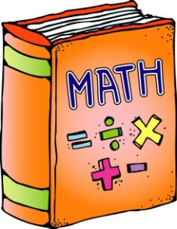 | 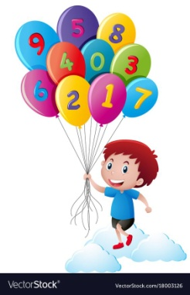  ORAL:  1. Counting from 1-5  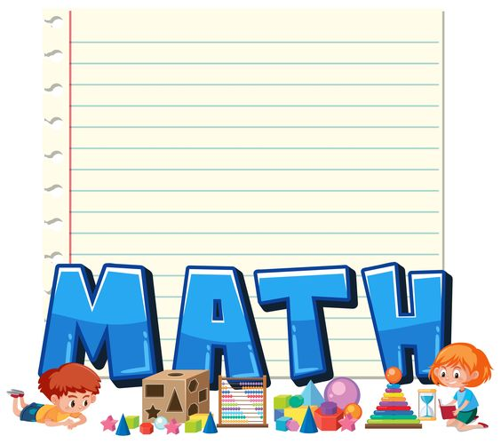  WRITTEN:  Standing lines, Sleeping lines, Slanting lines, Digits-1,2,3  Workbook- Page no. 9-16 | Counting Song  https://www.youtube.com/watch?v=JT0MmZcJ2Vw  Introduction to Shapes through “Shapes song”  https://www.youtube.com/watch?v=QBD7CB-rroo  Activity Work  - ‘Look and Identify’ Game related to ‘Big-Small’ objects, ‘Fat-Thin’ objects, ‘Up-down’ objects, etc.  - Learners will be asked to count the objects asked by the educator. | - Motivate your child in counting objects  - Help your child in learning counting.  - Help your child in doing his/her homework.

SUBJECTS | SYLLABUS | ACTIVITY + USE OF ICT | PARENTS INVOLMENT
ART & CRAFT | Page no. 6-7  Craft- Paper Rainbow, Clay Moulding, Face Expression Drawing | Introduction to Shapes through “Shapes song”  https://www.youtube.com/watch?v=QBD7CB-rroo  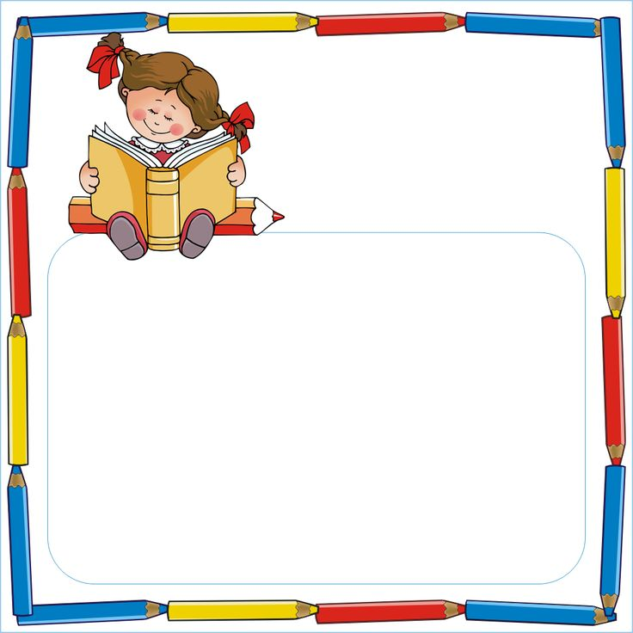  Activity Work  - ‘Look and Identify’ Shapes Game  - ‘Cut and Paste’ Game of different objects. | - Help your child to identify the shapes of daily life objects.
GENERAL KNOWLEDGE | Tasty Fruits- Apple, Mango, Banana, Papaya, Orange, Grapes  Healthy Vegetables- Potato, Onion, Tomato, Brinjal, Chilly, Cabbage  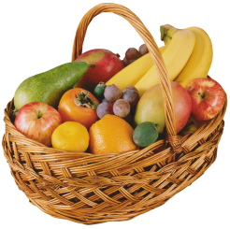 | Parts of the body  https://www.youtube.com/watch?v=SUt8q0EKbms Tasty Fruits  https://youtu.be/DiV48J0uB_Y  Activity Work  - Make a fruit chart pasting the  pictures of fruits. | - Help your child to identify the fruits and vegetables.
VALUE EDUCATION | I love my teachers. | Moral Story  https://www.youtube.com/watch?v=MEVyl3jq_3c | - Make your child learn the names of family members.
PHYSICAL EDUCATION | Fun Games- Running, Jumping, Hopping | DO EXERCISE THROUGH THIS LINK  https://www.youtube.com/watch?v=JoF_d5sgGgc | - Take your child to a park and play some games.
DANCE | 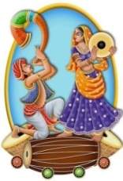  I love my India… |  | - Help your child to learn good habits.  - Help your child in participating in school activities.
MUSIC | National Anthem,  Gayatri Mantra, Prayer,  Patriotic Song, Devotional Song | https://www.youtube.com/watch?v=RqQ4asI70Bg  https://www.youtube.com/watch?v=SPm-Qy5m39E | - Help your child to learn the prayers.
MOTOR SKILL DEVELOPMENT | 1. How to do Namaste  2. How to walk in a straight line  3. How to sit gracefully on the chair  4. How to use the washroom and wash hands | REFER THIS LINK  https://www.youtube.com/watch?v=wh6gt3IkRKk | - Help your child in practicing these skills at home.
LANGUAGE DEVELOPMENT | This is my school. | MY SCHOOL- https://www.facebook.com/watch/?v=25316 31197059981 | - Make your child learn the name of school.

SUBJECTS | SYLLABUS | ACTIVITY + USE OF ICT | PARENTS INVOLMENT
CONVERSATION | ENGLISH CONVERSATION  1. What is your name?  Ans. My name is .  2. How are you?  Ans. I am fine, thank you.  3. How old are you?  Ans. I am 3 years old.  4. In which class do you study?  Ans. I study in class Nursery. | HINDI CONVERSATION  1- vkidk D;k uke gS\  m& esjk uke gSA  2- vki fdrus o’kZ ds gSa\  m& eSa rhu o’kZ dk gw¡A  3- vki dSls gS\  m& eSa vPNk@vPNh gw¡A  4- vki fdl d{kk esa i<+rs gSA  m& eS d{kk --- esa i<rk@i<+rh gw¡A | - Help your child in learning conversation questions.
 | 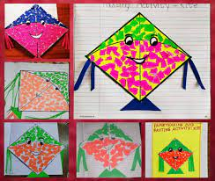  July-  Tearing & Pasting Paper & Pencil Shaving Activity  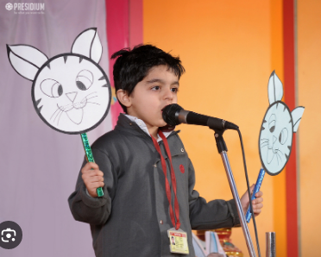  Story Telling-  1. Thirsty Crow  2. The Lion and the Mouse  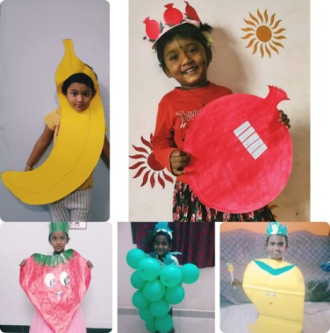  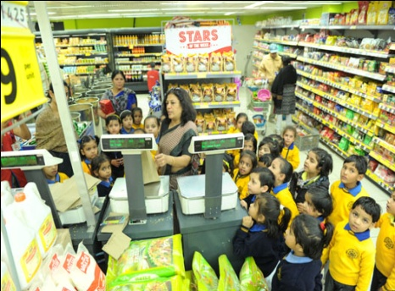  Fruit Day Celebration  Visit to a Departmental Store |  | 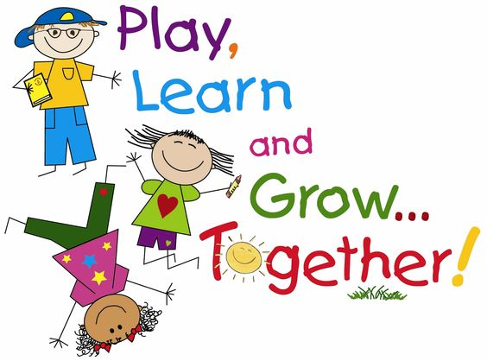

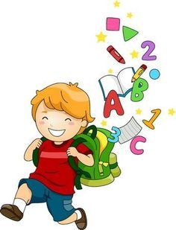
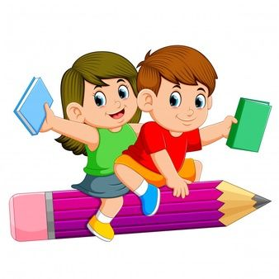
GREENWOOD PUBLIC SCHOOL
ADITYAPURAM, GWALIOR
SESSION 2023-24 : SYLLABUS FOR THE MONTH OF JULY : CLASS-LKG
SUBJECTS | SYLLABUS | ACTIVITY + USE OF ICT | PARENTS INVOLMENT
ENGLISH | ORAL:  Rhymes-  1. Toy Shop  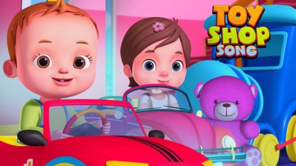  2. My Family  Revision of previous rhymes  Reading-Revision of Alphabets (A-Z), Phonic Sound of letters (Page no. 5-11)  Vocabulary Building- Chair, table, chalk, bench, school, duster, black board  WRITTEN:  Revision of Capital Letters (A-Z),  Small Cursive letters (a-j),  Match the following,  Write the first letter of the picture,  Vowels and consonants, Dictation | Rhymes-  Toy Shop  https://youtu.be/DONOHJ8yDZY  My Family  https://youtu.be/GV4Cr2FJm-Q  Phonics Sound  https://www.youtube.com/watch?v=hq3yfQnllfQ  Alphabet Song  https://www.youtube.com/watch?v=zAlX1V3lK5s  Vowels Song  https://www.youtube.com/watch?v=RUSCz41aDug  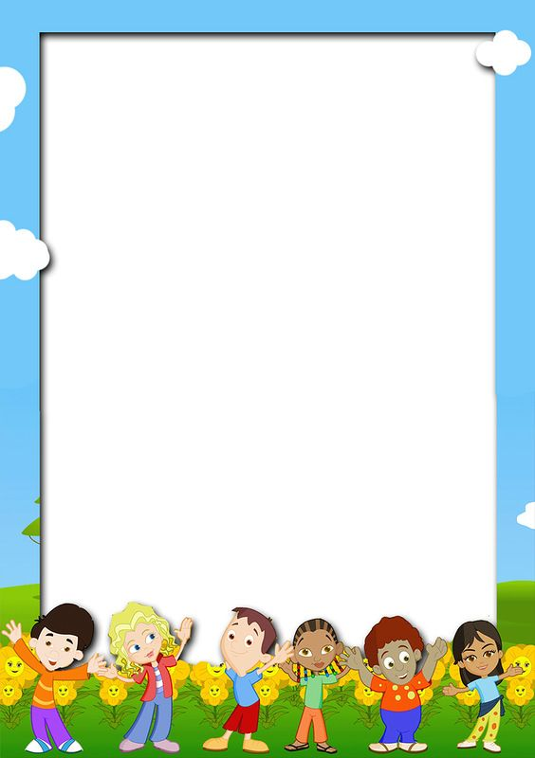  Activity Work  - ‘Look and Identify’ Game will be played for the recapitulation of the letters and their related objects. Learners will be asked to look and identify the objects as shown by the teacher.  - ‘Show and Tell’ Picture Reading Activity | - Help your child in learning rhymes.  - Help your child in doing his/her homework.  - Motivate your child to use the vocabulary words in daily life.
SUBJECTS | SYLLABUS | ACTIVITY + USE OF ICT | PARENTS INVOLMENT
HINDI | ORAL:  dfork,¡&  1- xjeh th vc bye bye 2- frryh jkuh 3- losjk 4- lwjt esa gS rsjh ykyh  iBu&ikBu % 'kCn ist ua 8&19 rd  v{kjekyk& Loj % v ls v% rd dk iqu% vH;kl  O;atu o.kZ& d ls .k rd  WRITTEN:  o.kZekyk& Loj ¼v ls v% rd½ vkSj  O;atu ¼d ls .k rd½ fp= igpkudj v{kj fyf[k,] tksM+h feykb,] fp= ns[kdj çFke v{kj ij xksyk yxkb,] Jqrys[k | dfork,¡&  1- losjk  https://www.youtube.com/watch?v=N2x3V-8CCzA  2- lwjt esa gS rsjh rkyh  https://youtu.be/mWvTIPl2Fl4  o.kZekyk  https://www.youtube.com/watch?v=GBWGNvHsiFs  Activity Work  - dforkvksa dks lLoj okpu  - ns[kks vkSj crkvksaÞ [ksy ls fp=ksa dks igpkudj crk,¡A  - ^ns[kksa vkSj crkvks* [ksy ds tfj, o.kksaZ dks igpkub, ,oa crkb,sA | - cPpksa dks O;atuksa ls lacaf/kr fp=@oLrq,¡ igpkuusa esa lgk;rk djsaA  - cPpksa dks dfork fofHkUu Hkkoksa rFkk eqnzkvksa lfgr ;kn djkus ds fy, çksRlkfgr djsaA
 | ORAL:  Counting- 1 to 50,  Table of 2,  Number Names 1-5,  Revision of shapes and comparison of Long-Short, Near-Far, Tall-Short, Heavy-Light (Book Page no.7-32), Numeracy Skills  WRITTEN:  Counting from 1 to 50, Write the missing numbers, Dictation, Circle the odd one out, Count and Match, What comes before and after, Table of 2 | Counting-  https://www.youtube.com/watch?v=B5iAW-jnkPw  Table of 2-  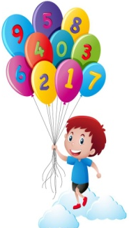  https://www.youtube.com/watch?v=VKJ9cCQgPdc  Opposite Words  https://www.youtube.com/watch?v=HGeuA4iJ8vI | - Motivate your child in counting objects  - Help your child in learning counting.  - Help your child in doing his/her homework.

SUBJECTS | SYLLABUS | ACTIVITY + USE OF ICT | PARENTS INVOLMENT
ART &  CRAFT | Colour Code Activity, Shapes  Craft- Table Mat Making | Activity Work  - ‘Cut and Paste’ Game of different objects related to rain. | - Help your child to identify the shapes of daily life objects.
GENERAL KNOWLEDGE | Oral:  Different flowers colours,  Parts of a plant  (Identification of pictures) | Activity Work  - ‘Cut and Paste’ Game through the pictures of parts of a plant. | - Help your child to identify the parts of a plant.  - Discuss with your child about flowers and their colours.
VALUE EDUCATION | Help your friends | Moral Story  https://www.youtube.com/watch?v=MEVyl3jq_3c | - Instil in your child the habit of speaking the truth.
PHYSICAL EDUCATION | Fun Games- Catching, Throwing, Skipping and Yoga | DO EXERCISE THROUGH THIS LINK  https://www.youtube.com/watch?v=JoF_d5sgGgc | - Take your child to a park and play some games.
DANCE | 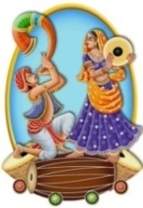  I love my India… |  | - Motivate your child in participating in school activities.
MUSIC | National Anthem,  Gayatri Mantra, Prayer,  Patriotic Song, Devotional Song | https://www.youtube.com/watch?v=RqQ4asI70Bg  https://www.youtube.com/watch?v=SPm-Qy5m39E | - Help your child in learning the prayers.
LANGUAGE DEVELOPMENT | Monsoon, Puddle, Drench, Thunder, Lightning, Rain, Sink, Float | Do’s and Don’ts during Rainy Season  - Use umbrella and raincoat.  - Do not play in muddy water.
MOTOR SKILL DEVELOPMENT | 1. How to do Namaste?  2. How to walk in a straight line?  3. How to sit gracefully on the chair?  4. How to use the washroom and wash hands? | REFER THIS LINK  https://www.youtube.com/watch?v=wh6gt3IkRKk | - Help your child in practicing these skills at home.
EXPERIMENT | Topic- Water is Colourless, tasteless

SUBJECTS | SYLLABUS | ACTIVITY + USE OF ICT | PARENTS INVOLMENT
CONVERSATION | English Conversation  Q-1 What is your name?  Ans- My name is______.  Q-2 What is your Father’s name?  Ans- My Father’s name is__________.  Q-3 What is your Mother’s name?  Ans- My Mother’s name is__________.  Q-4 In which class do you study?  Ans- I study in Class L.K.G.  Q-5 How old are you?  Ans- I am__years old.  Q-6 What is the name of your Class teacher?  Ans- My Class teacher’s name is_________. | Hindi Conversation  1- vkidk D;k uke gS\  m& esjk uke ---------------- gSA  2- vkids ikik dk D;k uke gS\  m& esjs ikik dk uke ------------ gSA  3- vkidh eEeh dk D;k uke gS\  m& esjh eEeh dk uke Jherh ----------- gSA  4- vki fdl d{kk esa i<+rs gSa\  m& eSa d{kk L.K.G. esa i<+rk gw¡@i<+rh gw¡A  5- vki fdrus o’kZ ds gSa\  m& eSa ---- o’kZ dk@dh gw¡A | - Help your child in learning conversation questions.
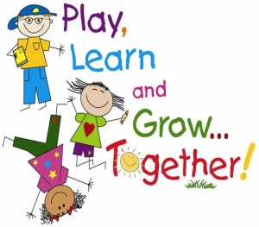 | July-  Tearing & Pasting Paper & Pencil Shaving Activity  Story Telling-  1. Thirsty Crow  2. The Lion and the Mouse  Fruit Day Celebration  Visit to a Departmental Store |  | WATER  Water is precious  Water is cool  Drink it when I am thirsty  At home and at school  Water is wet  Water is fun  I play in the little water pool,  Under the storm.
GREENWOOD PUBLIC SCHOOL
ADITYAPURAM, GWALIOR
SESSION 2023-24 : SYLLABUS FOR THE MONTH OF JULY : CLASS-UKG
SUBJECTS | SYLLABUS | ACTIVITY + USE OF ICT | PARENTS INVOLMENT
ENGLISH | ORAL:  Rhymes-  1. One, Two, Three, Four, Five  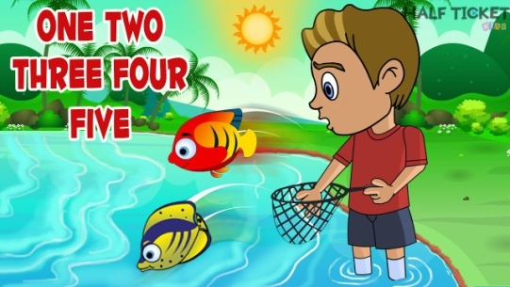  2. My Body  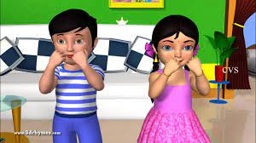  Sentence Structure-  1. I am going to school/market.  2. I am playing/studying.  Reading- English Primer Page no.7,8,9  Vocabulary Building- Rain, Umbrella, Gumboots, Raincoat, Paper boat  WRITTEN:  Revision of Capital and Small Cursive Letters A-Z, Sound of vowel a and e | Phonics Sound  https://www.youtube.com/watch?v=hq3yfQnllfQ  Vowels Song  https://www.youtube.com/watch?v=RUSCz41aDug  Sound of ‘a’  https://www.youtube.com/watch?v=Sno15qcDEr4  Activity Work  - ‘Read and Tell’ Game will be played for the three letters words. Learners will be asked to read the words as shown by the teacher. | - Help your child in learning rhymes.  - Help your child in doing his/her homework.  - Motivate your child to read three letter words daily at home.
SUBJECTS | SYLLABUS | ACTIVITY + USE OF ICT | PARENTS INVOLMENT
HINDI | dfork,¡&  - thou lq/kjsxk 2- Mkfd;k vk;k  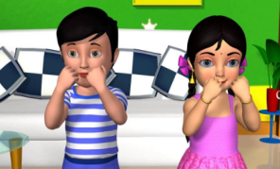  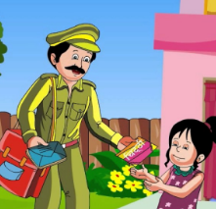  iBu ikBu& vk dh ek=k] dfork xku] b dh ek=k] bZ dh ek=k  okD; jpuk&  1-gesa vius ekrk firk dk dguk ekuuk pkfg,A  2- gesa dHkh Hkh ykyp ugha djuk pkfg,A  fyf[kr%&  vH;kl iqLrd& i`’B Øekad& 33 ls 43 rd  ikB&8% vk dh ek=k ¼k½  ikB&9% dfork xku  ikB&10% b dh ek=k ¼f ½  ikB&11% bZ dh ek=k ¼ h½ | o.kZekyk  https://www.youtube.com/watch?v=GBWGNvHsiFs  nks v{kj okys “kCn  https://www.youtube.com/watch?v=eiiahBq5Zt0  rhu v{kj okys “kCn  https://www.youtube.com/watch?v=3avCy9Kd1Og  pkj v{kj okys “kCn  https://www.youtube.com/watch?v=V86T7a6rArs  Activity Work  - dforkvksa dks lLoj okpu  - ns[kks vkSj crkvksaÞ [ksy ls fp=ksa dks igpkudj crk,¡A  - ^ns[kksa vkSj crkvks* [ksy ds tfj, fcuk ek=k okys ‘I dks if<+, ,oa crkb,sA | - cPpksa dks fcuk ek=k okys “kCnksa dks i<+us esa lgk;rk djsaA  - cPpksa dks dfork fofHkUu Hkkoksa rFkk eqnzkvksa lfgr ;kn djkus ds fy, çksRlkfgr djsaA

SUBJECTS | SYLLABUS | ACTIVITY + USE OF ICT | PARENTS INVOLMENT
 | 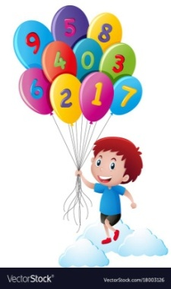  ORAL:  1. Counting from 1-150  2. Tables of 2 - 4  3. Number names from 1 to 20  WRITTEN:  Counting from 1 to 200  Tables of 2 and 5  Number names from 1 to 30  Backward Counting from 20 to 1 | Counting-  https://www.youtube.com/watch?v=B5iAW-jnkPw  Table of 2-  https://www.youtube.com/watch?v=VKJ9cCQgPdc  Table of 3-  https://www.youtube.com/watch?v=v10unhK-3uU  Number Names  https://www.youtube.com/watch?v=LyvQ6pc7JSA  Activity Work  - ‘Look and Identify’ Number Game  - ‘Count and Tell’ Game. Learners will be asked to count the objects asked by the educator.  - ‘Dodging’ Game from the table of 2, 3 and 4 | - Motivate your child in counting objects  - Help your child in learning counting.  - Help your child in doing his/her homework.
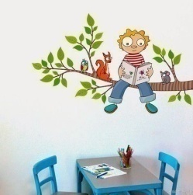  EVS | ORAL:  1. Our Family- Father, Mother, Brother, Sister  2. Parts of a plant-Stem, Roots, Fruit, Leaf  WRITTEN:  Ch-1: Our Family  Ch-2: Our House  Parts of a plant | Body Parts  https://www.youtube.com/watch?v=SUt8q0EKbms  Good Habits and Good Manners  https://www.youtube.com/watch?v=gwEgTQxZgw8 | - Help your child in doing his/her homework.  - Help your child to identify the body parts and ask their functions.  - Teach your child some good habits.
ART & CRAFT | Page no. 5,6,7  Craft- Table Mat Making | Activity Work  - ‘Cut and Paste’ Game of different objects related to rain. | - Help your child to identify the daily life objects.
PHYSICAL EDUCATION | 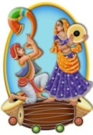  Catching, Throwing, Skipping and Yoga | DO EXERCISE THROUGH THIS LINK  https://www.youtube.com/watch?v=JoF_d5sgGgc | - Take your child to a park and play some games.
DANCE | I love my India… |  | - Help your child in participating in the school activities.
MUSIC | National Anthem, Gayatri Mantra,  Prayer, Patriotic Song, Devotional Song | https://www.youtube.com/watch?v=RqQ4asI70Bg  https://www.youtube.com/watch?v=SPm-Qy5m39E | - Help your child in learning the National Anthem & Song.
EXPERIMENT | Topic- Water is Colourless, tasteless

SUBJECTS | SYLLABUS | ACTIVITY + USE OF ICT | PARENTS INVOLMENT
GENERAL KNOWLEDGE | Flowers Names, Colours Names & Shapes | Activity Work  - Make a shapes chart pasting the  different colourful shapes. | - Help your child identify the flowers, colours and shapes.
VALUE EDUCATION | Help your friends | Moral Story  https://www.youtube.com/watch?v=ziXvFCKEGqM | - Teach your child to obey the elders.
MOTOR SKILL DEVELOPMENT | 1. How to do Namaste?  2. How to walk in a straight line?  3. How to sit gracefully on the chair?  4. How to use the washroom and wash hands? | REFER THIS LINK  https://www.youtube.com/watch?v=wh6gt3IkRKk | - Help your child in practicing these skills at home.
LANGUAGE DEVELOPMENT | Monsoon, Puddle, Drench, Thunder, Lightning, Rain, Sink, Float | Do’s and Don’ts during Rainy Season  - Use umbrella and raincoat.  - Do not play in muddy water. | -
CONVERSATION | ENGLISH CONVERSATION  1. What is your name?  Ans. My name is .  2. What is your father’s name?  Ans. My father’s name is .  3. What is your mother’s name?  Ans. My mother’s name is .  4. How old are you?  Ans. I am … years old.  5.What is the name of your school?  Ans. The name of my school is Greenwood Public School. | HINDI CONVERSATION  1- vkidk D;k uke gS\  m& esjk uke gSA  2- vkids firkth dk uke D;k gSa\  m& vkids firkth dk uke Jh gSA  3- vkidh ekrkth dk uke D;k gSa\  m& vkidh ekrkth dk uke Jherh gSA  4- vki fdrus o’kZ ds gSa\  m& eSa o’kZ dk gw¡A  5- vkids fo|ky; dk D;k uke gS\  m& esjs fo|ky; dk uke xzhuoqM ifCyd Ldwy gSA | - Help your child in learning conversation questions.
 | July-  Tearing & Pasting Paper & Pencil Shaving Activity  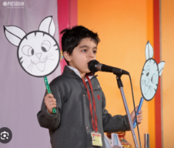  Story Telling-  1. Thirsty Crow  2. The Lion and the Mouse  Fruit Day Celebration  Visit to a Departmental Store  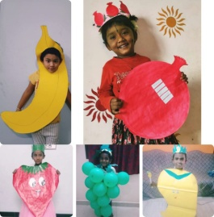  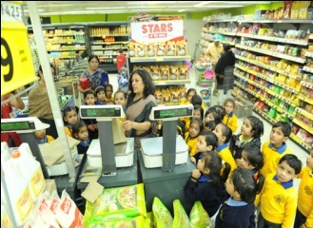 |  | WATER  Water is precious  Water is cool  Drink it when I am thirsty  At home and at school  Water is wet  Water is fun  I play in the little water pool,  Under the storm.

